Unit 6: The Rise and Fall of Modern Empires

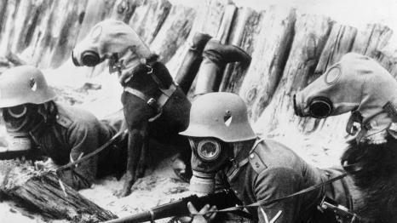 | 
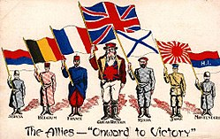 | 

General Information

Length of Unit – approximately 2 weeks
kgouge@wcpss.net
https://gougesocialstudies.weebly.com/9th-the-rise-and-fall-of-modern-empires.html

