Common Core Lesson Plan

Topic: Imperialism Title: The Suez Canal: A Lesson in Imperialism
This lesson focuses on European intervention in the Middle East after the Industrial Revolution.

Resources (primary resource documents, artifacts, material needs, etc.)
- Suez Canal PowerPoint
- Excerpts from Suez Canal by Ferdinand de Lesseps

Common Core Standards
- RH 1 - 6
- WHST 1, 4 - 10

Essential Standards
- 7.H.1.2, 7.H.2.1, 7.E.1.1, 7.C.1.1

Background Information
- Students will have been introduced to and have an understanding of and the reasons behind colonization.
- Students will have been introduced to and have an understanding of nationalism.

Instructional Sequence (before, during, and after instruction)

Step 1
Write the word Imperialism where your students can view it. Ask them to brainstorm in pairs to develop an eight word definition for the word. Ask for volunteers to share their definitions. Clarify any misconceptions or incorrect definitions.

Step 2
Begin the Suez Canal PowerPoint. Spend a few minutes on the title slide tracing the path of the Suez Canal.
(All of the pictures/images in the PowerPoint are primary source portraits and images and therefore can be analyzed as such.) Continue through the PowerPoint slides 1 - 5.

Step 3
On slide 6, ask the students to use the Think-Pair-Share activity to describe what happened during de Lesseps’ visit in Egypt.
1) Think. The teacher provokes students' thinking with a question or prompt or observation. The students should take a few moments (probably not minutes) just to THINK about the question.
2) Pair. Using a designated partner - nearby neighbors, or a deskmate, students PAIR up to talk about the answer each came up with. They compare their mental or written notes and identify the answers they think are best, most convincing, or most unique.
3) Share. After students talk in pairs for a few moments (again, usually not minutes), the teacher calls for pairs to SHARE their thinking with the rest of the class. She can do this by going around in round-robin fashion, calling on each pair; or she can take answers as they are called out (or as hands are raised). Often, the teacher or a designated helper will record these responses on the board or on the overhead.

Step 4
Give each student a Suez Canal excerpts reading. Ask them to highlight and annotate the reading.
Ask the students the following questions: What happened during his visit? How did he describe Egypt and the Khedive? Was his visit successful? How do you know?

Step 5
Continue with PowerPoint slides 7 – 8. The gentleman on the bottom of slide 8 is Benjamin Disraeli, the Prime Minister of Great Britain in 1875. Ask your students why he would be happy re: the selling of the Egyptian shares of the Suez Canal.

Step 6
Instruct your students to analyze the map on slide 9. Ask them why would Britain be interested in purchasing the shares? What would it mean to them? How do you know?

Share with your students how Britain bought the shares: Disraeli proposed the idea of buying the shares to Parliament, but was afraid that France would purchase the shares before they would appoint the funds for the purchase. Disraeli sent his private secretary to Lord Rothschild and asked the lord for a loan of 4 million to purchase the Canal shares. Lord Rothschild politely asked what collateral he had and the secretary said “The British Government”. Lord Rothschild made the loan.

Step 7
Continue to slide 10. Give each student a Cartoon Analysis Worksheet. Instruct them to analyze the cartoon on slide 10 using the worksheet. Review their answers.

Step 8
Give each student an additional copy of the Cartoon Analysis Worksheet. Instruct them to create their own political cartoon about the Suez Canal, then analyze the cartoon using the worksheet.

Excerpts from The Suez Canal by Ferdinand de Lesseps
from http://books.google.com/books?id=-81MQ5ALYYgC&pg=PA1&source=gbs_toc_r&cad=4#v=onepage&q&f=false

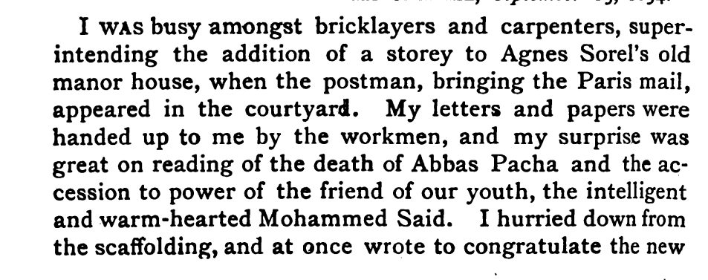
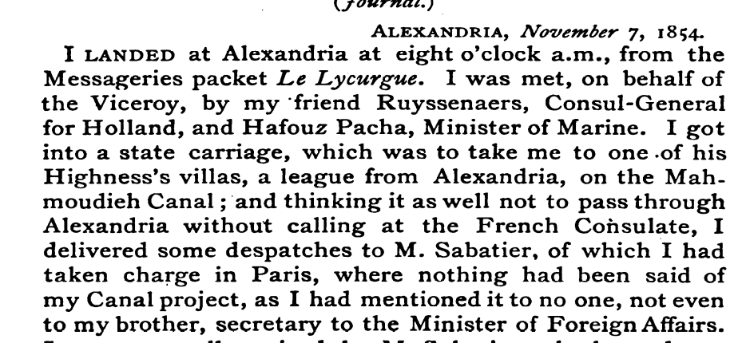
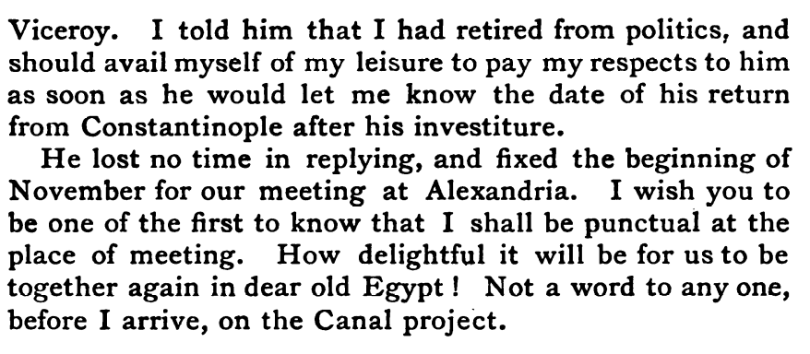
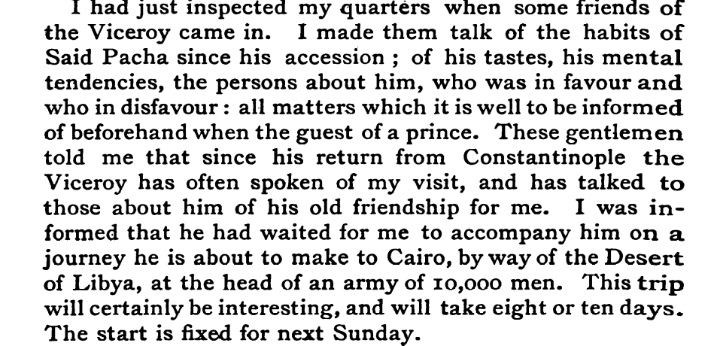
Why did de Lesseps not want his friend to say a word to anyone about the Canal project?
When de Lesseps arrived in Egypt, he asked about the habits, tastes, tendencies and persons about him. Why?
1
2
3
4

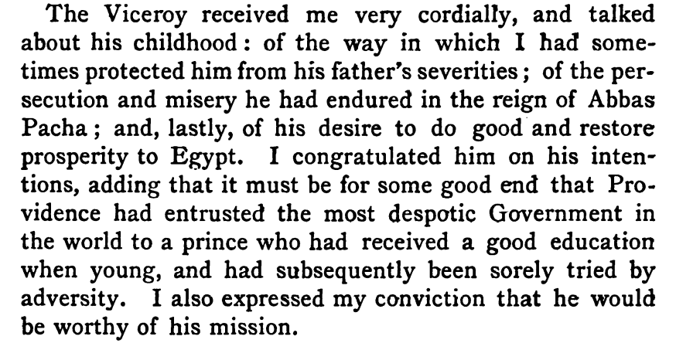
5

Why did de Lesseps hesitate in asking the Khedive (Viceroy) about the Suez Canal?

6

What do you think de Lesseps was thinking when he proposed his idea to the Khedive?

What do you think the Khedive was thinking when de Lesseps proposed his idea?

7

Excerpts from The Suez Canal by Ferdinand de Lesseps
from http://books.google.com/books?id=-81MQ5ALYYgC&pg=PA1&source=gbs_toc_r&cad=4#v=onepage&q&f=false

1
2
3
4

5

6

7

