England Taxes and Taxes
1. King George III becomes king in 1760 during the French and Indian War. He mission is to completely crush the French while strengthening the British Colonies around the world.
2. England inherits all lands in North America from the Mississippi to the Atlantic (called New France). Realizing how vast the new land is and the reality that it is too large for England to control Parliament governed the territory with more freedoms than anywhere else in the world.
3. Due to being heavily in debt, England cannot pay American colonists that served in the French and Indian War with money so instead they are paid in parcels of land. Many that accept the land for military service get use to living free of laws and excessive taxes on their new homes across the Appalachian Mountains.
4. By 1763, England is faced with the potential of a new war in America, this time with Chief Pontiac and an alliance of many native tribes. England cannot afford this war and as a compromise forbids American colonists from moving over the Appalachian Mountains, as well as requiring those already there to return to the 13 colonies.
5. Under joint orders of Parliament and King George the 13 colonies will be forced to pay the monetary debt of the French and Indian War through a string of new taxes on commonly used items in the New World.

America Boycotts and Protests
1. American Colonists offer to pay for a portion of the war debt in exchange for having a voice in Parliament. The slogan “no taxation without representation” begins to gain popularity in the 13 colonies.
2. As Parliament sanctions new taxes, Americans begin to protest the taxes through legal channels, petitioning the king, finding new ways to avoid the taxes and by a string of organized boycotts of anything made or produced by England. Many colonist know England is hurting for money and a boycott will financially put England in a potion to hear our demands.
3. As the Americans successfully boycott and protest the new taxes, Parliament will begin to repel each tax under the promise of compromise, but will ultimately replace the old tax with a new and more financially harsh tax.
4. Many wealthy and influential Americans begin to revisit Ben Franklin’s suggestions from the Albany Congress that maybe the American Colonies should unite as one governance to demand King George give us a vote/say in Parliamentary affairs.
5. Realizing that the possibility for a civil resolution is rapidly deteriorating, King George orders thousands of Redcoats to American shores to uphold law/order and intimidate the colonists back in control – with each new ship of Redcoats arriving American anger and lack of options grow.
6. As Redcoat control of the colonies increases with more physical intimidation, Samuel Adams and John Hancock form the Sons of Liberty to protect patriot citizens, patriot homes and patriot businesses, but in reality they exist to provoke the Redcoats with equal physical retaliation.

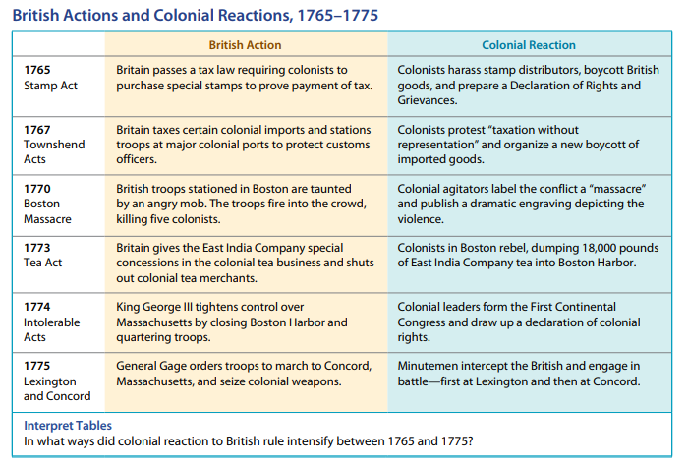

Influence of the Age of Enlightenment thinkers
1. Many wealthy, influential and educated Americans begin to heavily study and read the teachings and writings of the Enlightenment era thinkers. They begin to openly discuss the new learnings and ponder if the various economic, legal, social and political theories the Enlightenment addressed could in fact come to fruition in the American colonies:
- John Locke: The power of any king or government is derived from people who contract to obey their rules in exchange for law and security. Individuals have a natural right to hold property and this can never be taken from them without their own consent. If a ruler infringes the terms of the contract that empowers him or seizes property without consent, the people can resist and depose him
- Jean Jacques Rousseau: Government should exist in a way that protects society and its citizens, citizens in return should enter into a “Social Contract” where good people will do things that result in the greater good for society (ie: a system of laws that benefit all) . Rousseau believed that all people where born free, but lived their life in chains and bondage by corrupt governments and the only way to limit a government was to have the Social Contract on a political level – powers of government should be restricted so that good people can be free.
- Lord Montesquieu: Power of government is something that will ultimately become corrupted and hurt the very citizens it was created to protect, therefore to make sure that the citizens are protected by the government, its powers should be divided into three separate branches each equal with power but separate in how they apply their power.
- Thomas Hobbes: How can people live together and not think of fighting - by agreeing to obey a leader that is in power and resisting human desire to do things as they “want” for their own good. Humans should be controlled and give of their own desires. If the government is strong the people will be strong. It is the duty of all people to make the government strong.

Tensions Grow
1. By 1770, cities such as Philadelphia, New York and Boston have become the focus of the impending war. Under Redcoat control, King George’s laws and Parliaments taxes, the citizens have hit a tipping point and begin to physically protest in the streets. You can now feel a change in the relationship of England and her American colonies.
2. In response to the Boston Massacre, Sons of Liberty take control of British Merchandise ships in Boston Harbor and dump over 18,000 pounds of tea into the water.
3. In response to the Boston Tea Party, Parliament imposes the Intolerable Acts. With Boston now under martial law, citizens outside the city begin to arm themselves and form a militia that will be ready to fight within a minutes notice – they call themselves the “minutemen”.
4. Sensing that this tension could lead to an all out war, Franklin and Jefferson call on each colony to write letters to King George/Parliament – these Committees of Correspondence are intended to let King George know of desire to stay a part of the British Empire but that we also have needs that must be met.
5. The committees have the opposite effect and only outrage England more. Now the colonies meet together as one body in Philadelphia to officially petition the King – this 1st Continental Congress will attempt one last time to reassure England that we do not wish to leave, that we wish a peaceful solution that includes our demands and that only as a last resort America will begin to defend herself.
6. Knowing that a rebellion is probably inevitable, Parliament orders the Redcoats to suppress all resurrections and arrest all agitators. The order is given to take 1700 troops and arrest all minutemen training to fight at their base in nearby Lexington Massachusetts. On April 19th, 1774 Patriots and Redcoats will clash at the Battles of Lexington and Concord – the world stood in disbelief and awe that “farmers” and “militia” from one of England’s own colonies had opened fire and fought the Redcoats that this moment is called “The Shot Heard Round the World”.
7. Faced with the reality that Colonial militia have now fired on English troops, that colonies such as NC have already sent the King notice that they are leaving the British Empire, Franklin calls the members of the 1st Continental Congress back to Philadelphia for a 2nd Continental Congress. After much debate, the founding fathers realize that war is inevitable and officially send on behalf of all the British American Colonies the Declaration of Independence.
8. The Declaration of Independence is written with four parts: a preamble, a list of human rights, a list of grievances against the English and an official declaration that they are no longer British, but now free and independent Americans.

